New Leadership Oregon Facts
A Women’s Leadership Program offered by PSU’s Center for Women’s Leadership
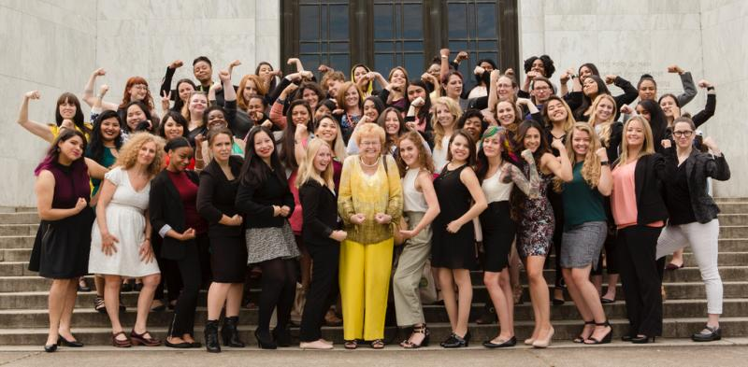

What is New Leadership Oregon?
NEW Leadership Oregon is the award-winning women's leadership development program housed at the Center for Women's Leadership at Portland State University. Open to college women enrolled at any college in the state of Oregon, NEW Leadership Oregon runs an inclusive women-centered leadership program that educates and encourages outstanding college women to develop paths towards leadership.

Who is eligible to attend?
Any woman enrolled in an Oregon college or university during the current academic school year is eligible to apply. Students at the undergraduate and graduate level are welcome and students with all kinds of interests and backgrounds are encouraged to apply. The application pool is very diverse. Applications are accepted from late fall to the following February. Typically, almost 150 applications are submitted for 40 program spots. CWL board members review applications and choose program participants. Typically, more than 18 colleges from all over the state are represented by program participants.

What is the program like?
The program, offered at the end of June, is residential, which means the participant will be staying in the PSU residence halls from Thursday through Tuesday, and attending sessions or work meetings every day. There are between three and five sessions or activities per day, and a trip to Salem to tour the Capitol and meet with elected officials.

What do NLO participants learn?
NEW Leadership Oregon teaches leadership through action. Participants:
- Practice public speaking, planning, organizing, and networking to address real social problems.
- Draw on the expertise of seasoned coaches and the experiences of women leaders in government, business, science, and the community.
- Learn a set of skills designed specifically to prepare college women for public leadership.
NEW Leadership Oregon's ongoing program starts with an intensive, six-day, residential leadership training, specifically designed to introduce Oregon's college women to opportunities for leadership. In addition, there is a September Training Day to address issues such as wage negotiation (Start Smart), board service, and career enhancement. There is also ongoing networking, mentoring and educational opportunities. By participating in the NEW Leadership Oregon program, college women find out why and how to develop their own leadership skills through interaction with Oregon's past and present women officeholders, business leaders, policy specialists, and activists. Hands-on skills-building workshops teach women to lead by taking action.

How much does the program cost?
Thanks to the generosity of our donors, NEW Leadership Oregon only costs participants a program fee of $250, and there is a significant scholarship program, as CWL is committed to making the experience accessible for all. The actual cost for development, food, housing, and program materials for the six-day program is closer to $1,500.

What happens at the end of NEW Leadership Oregon?
The Center for Women's Leadership is committed to providing ongoing mentorship and support to each of the Alumna for as long as she needs it and when she needs it. Participants will return to PSU in September following the June program for an additional training day, but will always have access to the support of the CWL Staff and network. The Alumnae Council composed of over 400 graduates has worked on developing a mentoring service for program graduates.

